Chapter 8 Rocks: The Rock Cycle
Name:
Figure 8.3.1 is a diagram of the rock cycle.
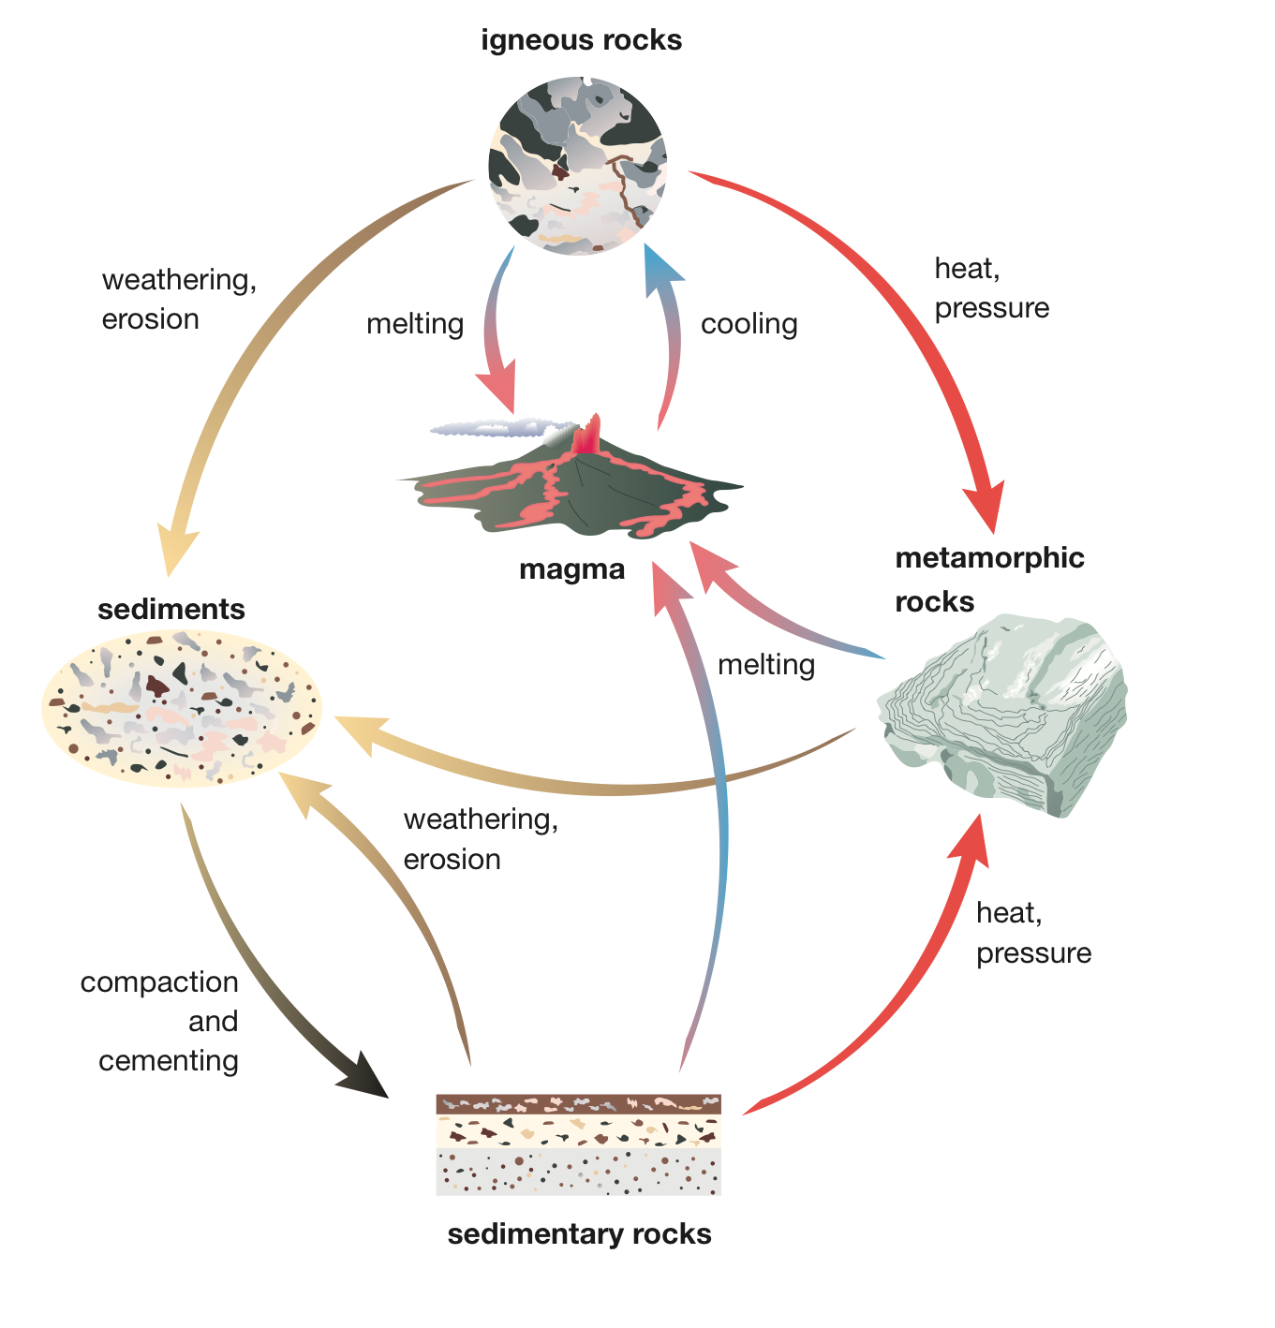
Figure 8.3.1

Questions
1 Starting at magma in the diagram, identify which type of rock forms first, and the process by which it forms.

2 Once an igneous rock forms, explain how can it be recycled to become an igneous rock again.

3 Identify the processes that turn an igneous rock into a sedimentary rock.

4 Identify the processes that turn an igneous rock into a metamorphic rock.

5 Identify the processes that change metamorphic rocks into sedimentary rocks.

6 Identify the processes that change sedimentary rocks into metamorphic rocks.

7 Explain how a sedimentary rock can turn into an igneous rock.

8 Explain how the rock cycle is a useful model in geology.

